|  |  |
| --- | --- |
|  | **Faculty of Industry and Energy Technology** |

**Ducks Row**

A capstone project submitted to faculty of Industry and Energy Technology, New Cairo Technological University, In partial fulfillment of the requirements for the Degree of Higher Diploma

**Information and Communications Technology**

**Submitted by**

|  |  |
| --- | --- |
| Abdallah Gamal Mohamed | Omar Eid Abd al-Hay |
| Kareem Abdallah Gelany | Amr El-Sayed Fawzy |
| Abdelrahman Ahmed | Abdelrahman Sherif Ahmed |

**Supervised by**

|  |
| --- |
| **DR. Rasha Stohy**  Information and Communications Technology Department  faculty of Industry and Energy Technology  New Cairo Technological University  **Eng. Rana Mohamed**  Information and Communications Technology Department  faculty of Industry and Energy Technology  New Cairo Technological University |

|  |  |
| --- | --- |
|  | **Faculty of Industry and Energy Technology** |

**Approval Sheet**

**Ducks Row**

A capstone project submitted to faculty of Industry and Energy Technology, New Cairo Technological University, In partial fulfillment of the requirements for the Degree of Higher Diploma of Information and Communications Technology.

**Submitted by**

|  |
| --- |
| Kareem Abdallah Gelany |
| Abdallah Gamal Mohamed |
| Abdelrahman Ahmed |
| Abdelrahman Sherif Ahmed |
| Omar Eid Abd al-Hay |
| Amr El-Sayed Fawzy |

**DEDICATION**

*Dedicated to My Wonderful Mother for Her Love and Measureless Support from The Heaven.*

# ACKNOWLEDGMENT

First of all, I thank *" God* " for helping me to achieve this work and giving me the ability to finish this thesis in that satisfactory form*.*

I would like to express my sincere appreciation to my supervisors: ***Dr.*** ***Rasha Stohy and Eng. Rana Mohamed****.* I am very grateful for their strong effort, continuous support, and encouragement during the research study in this capstone project. They really influenced my way of thinking and developing the research ideas adopted in this project. Really, I can’t find the appropriate words to thank them. I am very grateful for their strong effort, continuous support, and encouragement during the research study in this capstone project.

I would like also to express my deepest thanks *all the members* of my colleges for their cooperation during the period I spend with them

to prepare this work.

I am extremely grateful to *my* *family, especially my father, and my mother*.

*Capstone Project Team*

# ABSTRACT

Duck's Row was created to make it easier for customers to choose the ideal entertainment time based on their budget. It might be time-consuming and difficult to choose the ideal location for enjoying, especially if you have few resources. Due to its user-friendly interface, users may easily traverse the website and choose the options that are best suited to their needs. Due to its huge database of restaurants, cafes, parks, and other fun options, users may find new places to hang out.

As a conclusion, for dealing with the issue of arranging an entertainment time with friends or by yourself. Users can enter their tastes and budget on a website that has been created to apply the process, and they will then obtain a list of selection recommendations that suit their needs.

TABLE OF CONTENTS

ACKNOWLEDGMENT IV

ABSTRACT V

LIST OF FIGURES VII

CHAPTER 1 9

INTRODUCTION 9

**1.** **1 Overview** 9

**1.** **2 Problem Statement** 9

**1.** **3 Capstone Project Objective** 9

**1.** **4 Capstone Project Methodology** 10

**1.** **5 Significance of Proposed Capstone Project** 11

CHAPTER 2 13

LITERATURE REVIEW 13

**2.** **1 Introduction** 13

**2.** **2 Solution Approaches** 13

CHAPTER 3 15

system design and implementation. 15

**3.** **1 Introduction** 15

**3.** **2 Problem Formulation** 15

**3.** **3 The Applied Approach** 15

**3.** **4 Code of Capstone Project** 15

CHAPTER 4 33

REAL WORLD APPLICATION 33

4. **1** **Related works** 34

CHAPTER 5 37

CONCLUSION AND FUTURE WORK 37

**5.** **1 Conclusions** 37

**5.** **2 Future Work** 37

Bibliography 40

# LIST OF FIGURES

Figure 1Home page 16

Figure 2 Services 16

Figure 3 About Us 17

Figure 4home page CSS code 17

Figure 5Home page HTML code 18

Figure 6 Navbar 18

Figure 7 before logging in 19

Figure 8 after the logging in 19

Figure 9 Login 20

Figure 10 Sign up 20

Figure 11 Login code 21

Figure 12 Sign up code 21

Figure 13 Profile 22

Figure 14 change password 22

Figure 15 Profile page Code 23

Figure 16 Entertainment time 23

Figure 17 Entertainment time Page Code 24

Figure 18 More information 25

Figure 19 More information code 25

Figure 20 My plans 26

Figure 21 User Plan code 26

Figure 22 User table 27

**CHAPTER 1**

**INTRODUCTION**

# CHAPTER 1

## INTRODUCTION

This chapter provides an overview of the project's context, problem statement, capstone objective, capstone methodology, and the significance of thesis. Finally, the organization of this capstone project.

### **1 Overview**

Duck's Row is a website that helps users find the perfect place to go out based on their budget. The website has a large database of restaurants, cafes, parks, and other entertainment options, and users can filter their search by location, price, and other criteria. Duck's Row also has a user-friendly interface that makes it easy to navigate and find the best deals.

### **2 Problem Statement**

The problem is a lot of teenagers have a problem with choosing the best place to hang out, which often leads to the cancellation of their plans. With so many options available, teenagers are often overloaded and find it difficult to make a decision that satisfies everyone's opinions, budgets, and interests. This may cause time wase and missed opportunities for having fun, Therefore, there is a need for a solution that simplifies and streamlines the decision-making process for teenagers when it comes to choose the best place to hang out.

### **3 Capstone** **Project Objective**

Our capstone project's main goal is to create a user-friendly website that offers customized recommendations for entertainment times depending on a user's budget. Teenagers should have an enjoyable time with their friends and their decision-making should be made easier for them. Users of the website will be able to limit their search results based on their budget. The website will give a complete database of entertainment time areas, including restaurants, cafes, parks, and other entertainment options. To help users in selecting their entertainment times, the website will also include interactive tools like user reviews and ratings. To know the user’s opinion on specific place.

### **4 Capstone Project Methodology**

The methodology of this research is summarized as follows:

Methodology

Our method for planning entertainment times is based on the following steps:

* Collect information about the user's preferences and budget.
* Generate a list of possible entertainment times that meet the user's criteria.
* Evaluate the possible entertainment times based on the user's preferences and budget.
* Recommend the best entertainment time to the user.

We collect information about the user's preferences and budget through a user interface on our website. The user can specify their preferences for activities, locations, and the maximum amount of money they are willing to spend.

We generate a list of possible entertainment times by searching a database of entertainment times. The database contains information about the location, cost, and activities offered at each entertainment time. We filter the list of entertainment times based on the user's preferences and budget.

We evaluate the possible entertainment times based on the user's preferences and budget. The score for each entertainment time is based on the following factors:

* The user's preferences for activities and locations.
* The cost of the entertainment time.
* The distance between the entertainment time and the user's current location

We recommend the best entertainment time to the user based on their score. The user can then choose a recommendation that is want to from all.

### **5 Significance of Proposed Capstone Project**

Our capstone project is significant because it addresses a real-case problem that people face when planning entertainment times. Our method is effective in helping users plan entertainment times that meet their needs. We have evaluated our method with a user study and found that it is effective in helping users plan entertainment times that meet their needs.

Our method can be used by people of all ages and interests. It is especially useful for people who have limited budgets or who are trying to plan a entertainment time for a large group of people. Our method can also be used by businesses to plan events for their employees or customers.

We believe that our method has the potential to make planning entertainment times easier and more enjoyable for people of all ages. We are excited to continue developing our method and making it available to a wider audience.

**CHAPTER 2**

**Literature Review**

# CHAPTER 2

## LITERATURE REVIEW

### **1 Introduction**

The suggested approach uses a web-based application that enables users to look for locations that satisfy requirements including location, spending limit, and preferred activity. Users of the service can also compare costs, receive directions, and request estimates from various merchants. The approach appeals to those who are on a budget because it is simple, available, and free.

### **2 Solution Approaches**

We used the MCDM approach with the WSM (Weighted Sum Model) method to evaluate possible entertainment times based on user preferences and budget. We identify three criteria that are important to users when selecting a entertainment time: cost, location, and activities offered. These criteria are assigned weights based on their relative importance to the user. We collect information about the user's preferences and budget through a user interface on our website and use the MCDM approach to evaluate possible entertainment times.

**CHAPTER 3**

**System design and implementation**

# CHAPTER 3

## system design and implementation.

### **1 Introduction**

In our capstone project, we use the MCDM methodology to evaluate possible entertainment times based on user preferences and budget. We identify three criteria that are important to users when selecting a entertainment time: cost, location, and activities offered.

### **2 Problem Formulation**

The problem we are trying to solve is to help users find the best entertainment time places based on their preferences and budget. To do this, we need to evaluate possible entertainment times based on multiple criteria, such as cost, location, and activities offered. This is a difficult decision-making challenge that needs to be approached carefully and professionally.

### 3 **The Applied Approach**

We use the following criteria to evaluate possible entertainment times:

* Cost: the total cost of the entertainment time, including food, drinks, and other expenses.
* Location: the distance between the entertainment time and the user's current location.
* Activities offered: the variety and quality of activities offered at the entertainment time.

Through a user interface on our website, we gather data about the user's choices and spending limit. The user has the option to define their favourite activities, locations, and maximum budget. to assess potential entertainment times in considering the user's preferences and money limitations.

### **4 Code of Capstone Project**

**Home Page Code: -**

This is the main page of the project. The main page have five sections including header and footer sections.

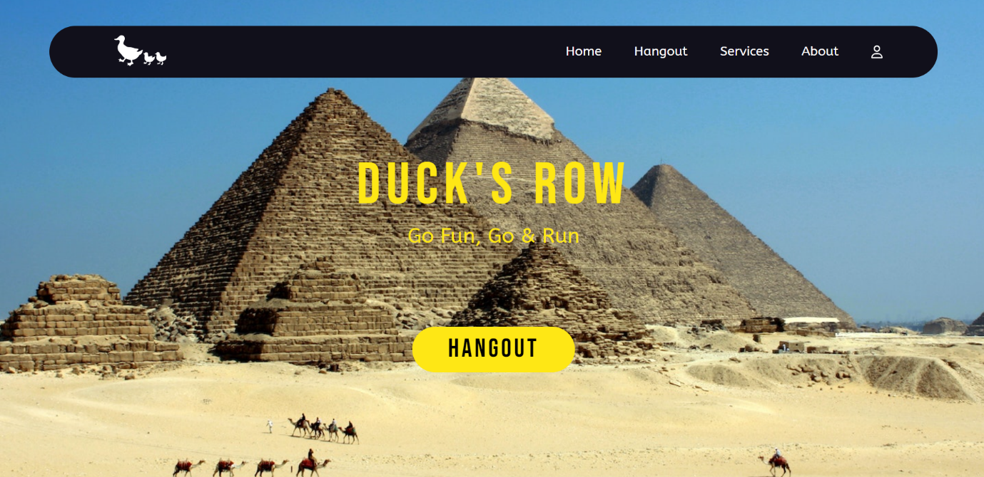

Figure 1Home page

Figure 2 Services

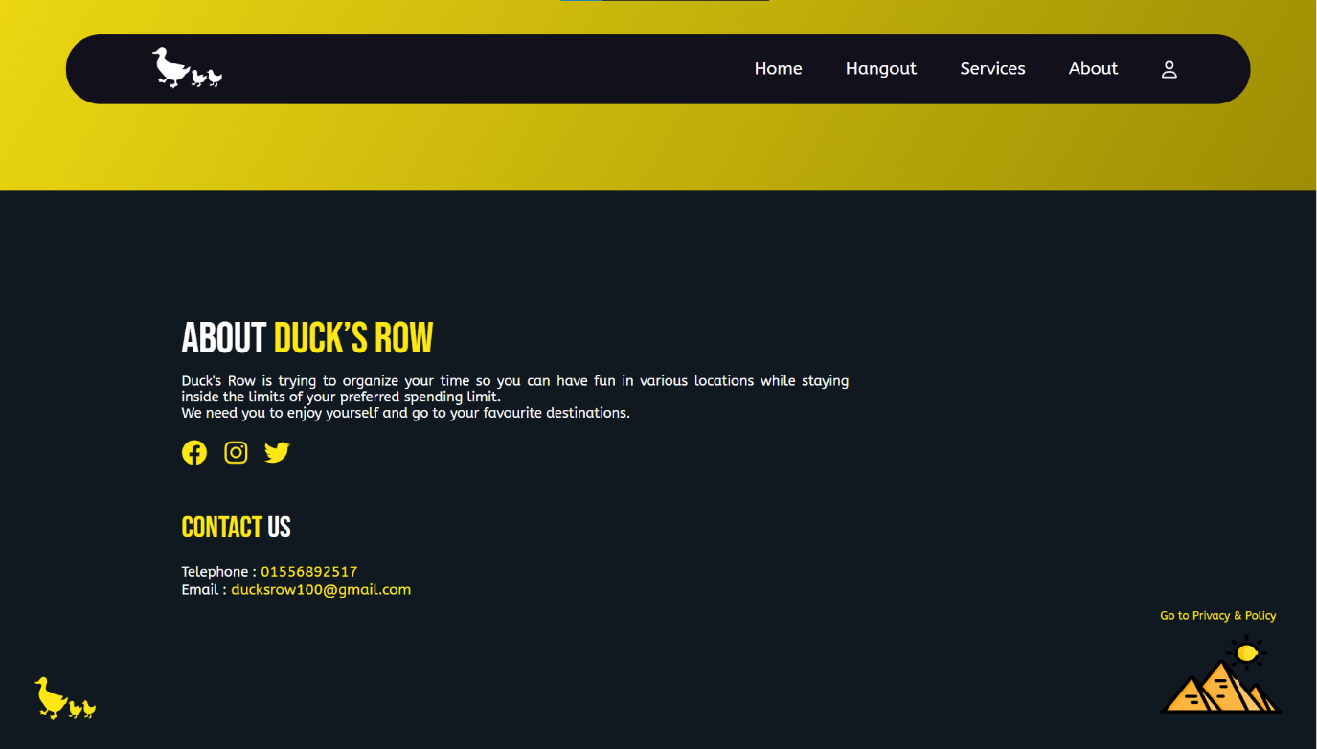

Figure 3 About Us

Figure 4home page CSS code

Figure 5Home page HTML code

**Navbar: -**

Our navigation has five links. Home link is making a smooth scrolling to the top of the page or the main view of the website. Entertainment time link is redirecting the page to the Entertainment time Page, Services and About is also making a smooth scrolling to the Services, and About sections, the user icon link is a drop list which has a login, and Sign up in case the user didn’t login, When he logged in the drop list will changed to have a user avatar, profile page link, and logout.



Figure 6 Navbar

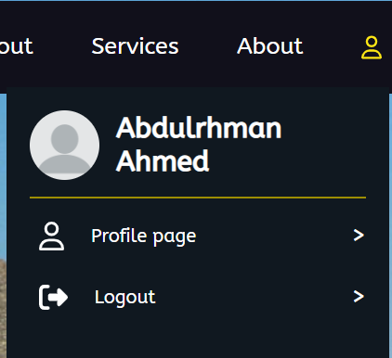

Figure 7 before logging in

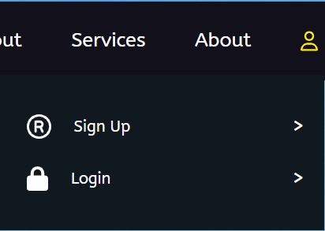

Figure 8 after the logging in

**Login and Signup: -**

In the Signup we took the main information about the user as his name, gender, or email address, in the login page the user is logging in with his password and the username.

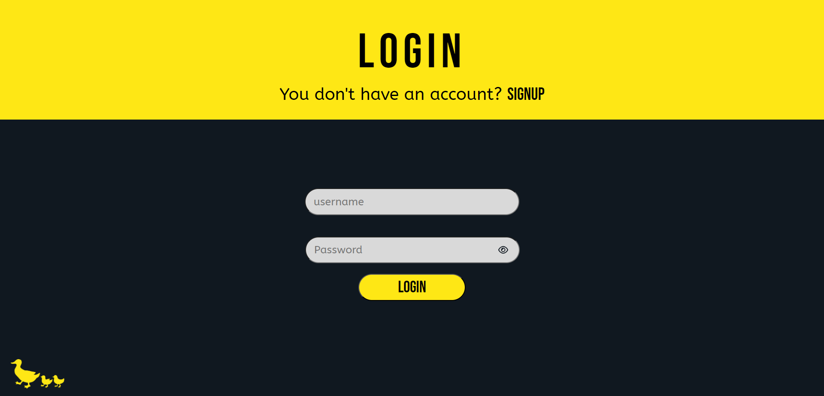

Figure 9 Login

Figure 10 Sign up

**Login Code: -**

We used PHP in the login and signup Codes.

Figure 11 Login code

**Sign up Code: -**

Figure 12 Sign up code

**Profile Page: -**

In the profile page we have two sections on the left we have the user avatar and he can upload any photo he likes, and the main buttons in the profile page. According to the left button activated the content on the right side is changed. In the profile we can Change the main data that you entered in the sign up.

Figure 13 Profile

**Change Password Page: -**

At the Same page as before the Profile page we can Change the password by clicking the Change password button at the left. In this page you are checking the current password. And after checking you can change the password as you want.

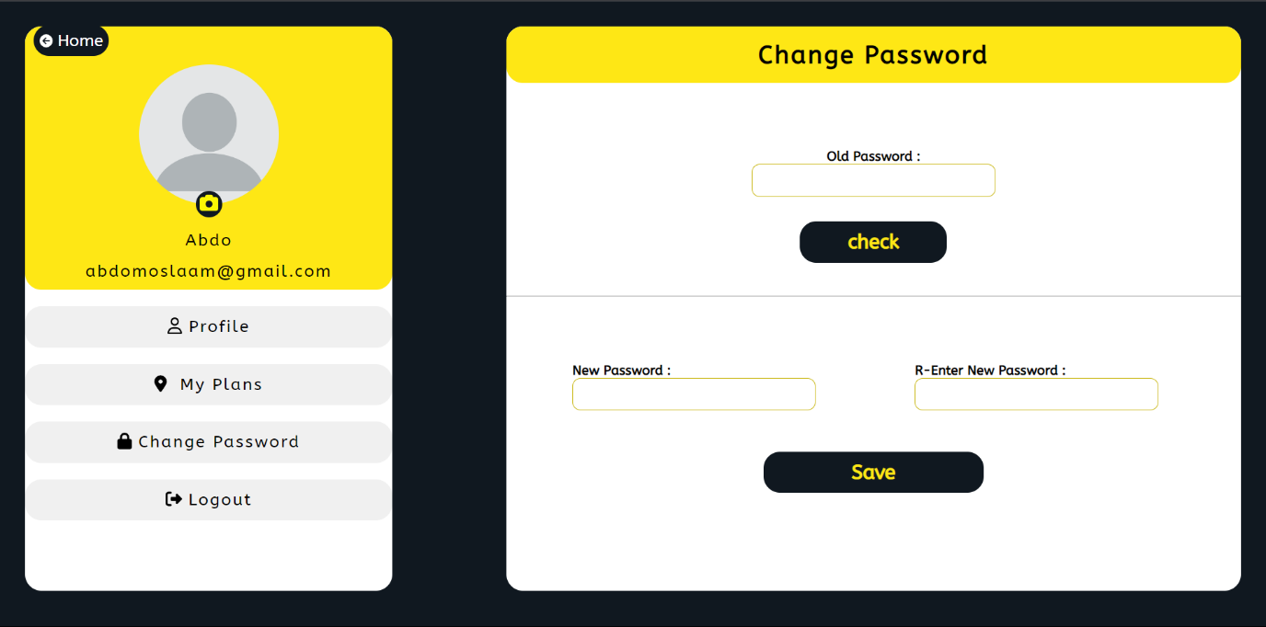

Figure 14 change password

Figure 15 Profile page Code

**Entertainment time Page: -**

The Entertainment time Page is the page where the user chooses his Cost for every place, Location, and activities. From the user choices the Cards of the places are changing. The More button is Showing more details about the place.

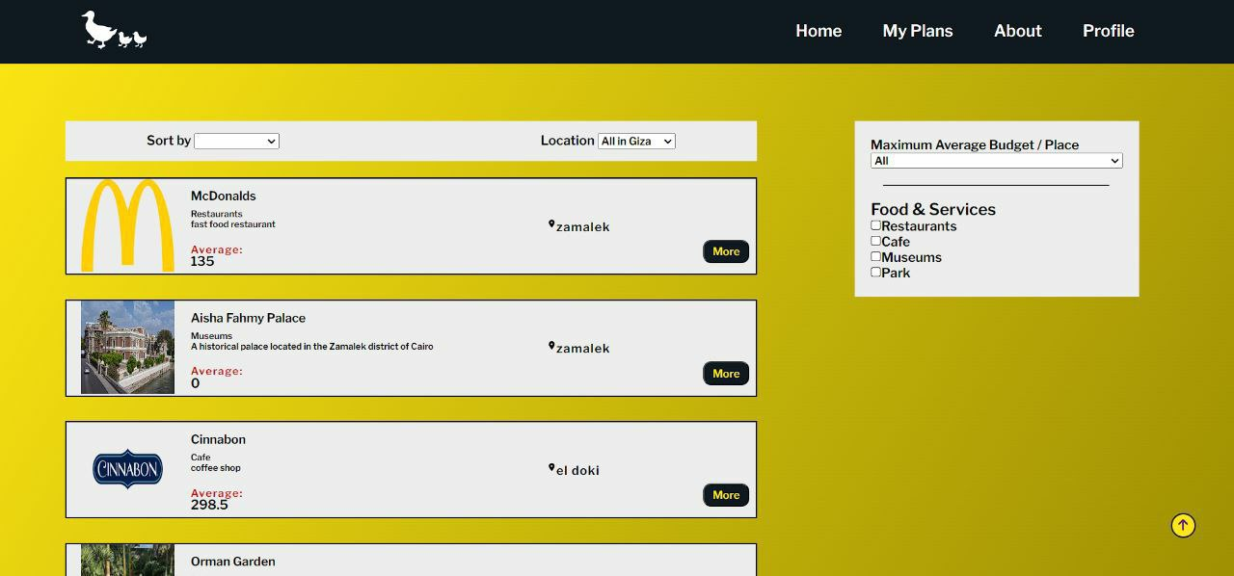

Figure 16 Entertainment time

Figure 17 Entertainment time Page Code

Filters: -

We have Four Filters: -

1. Sorting
2. Location
3. Cost
4. Activities

**More information about the place: -**

This place has more information about the place you choose as min or max budget, more details for the place, and the location of the place. By pressing on the “Add to my plans” the place is added to the “My plans” of the user.

Figure 18 More information

Figure 19 More information code

**The user Plan: -**

This page is the page that saves the places that you chose and the sum of the average of all the places. You can see more information about the place, or you can delete the place from your plan.

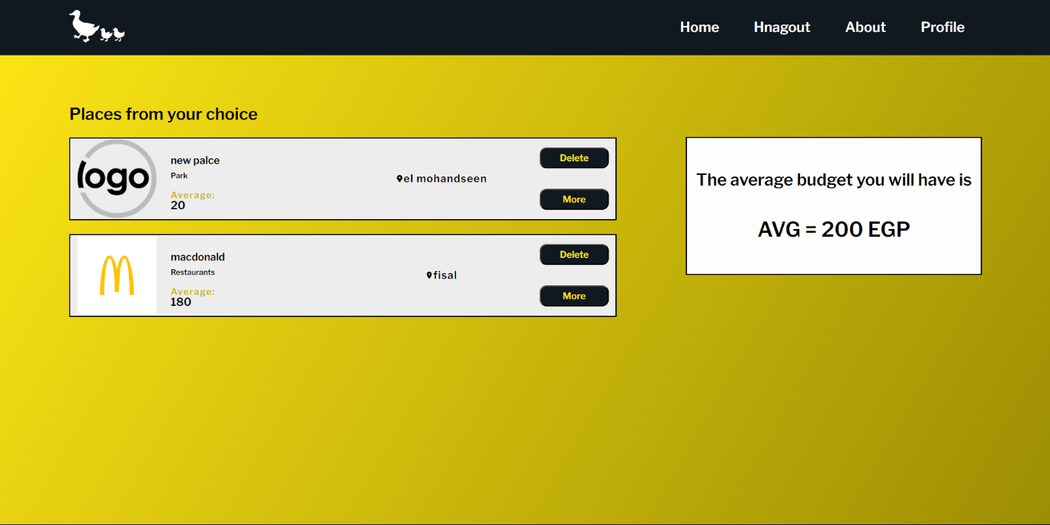

Figure 20 My plans

Figure 21 User Plan code

**Database: -**

* 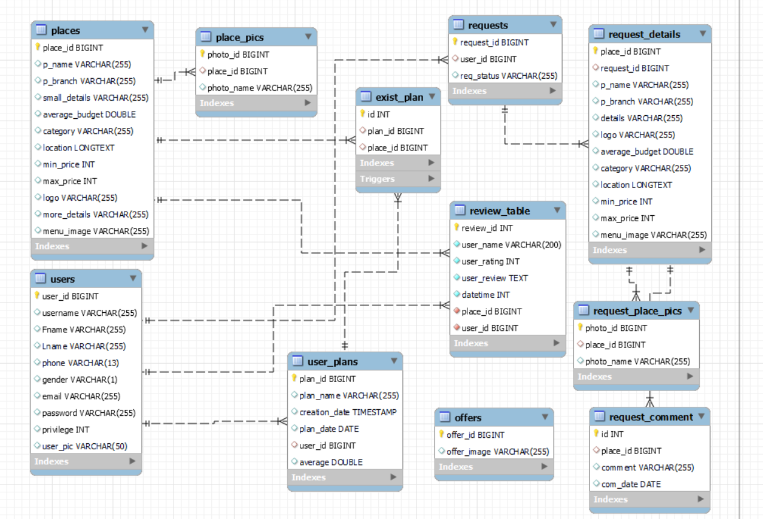**Enhanced entity-relationship (EER) diagram**
* A screenshot of a computer

  Description automatically generated with medium confidence**The ‘users’ table holds the information of all the website users with the ‘user_id’ being the primary key**

Figure 22 User table

* A screenshot of a computer

  Description automatically generated with low confidence**The ‘places’ table holds the information that’s connected to the places in the website with the ‘place_id’ being the primary key**

Figure 23 Places Database

* **The ‘places_pics’ table holds the photos that appear to the user inside the website for the places with the id being the primary key and the ‘place_id’ being the foreign key connecting the ‘place_pics’ table with the places table**

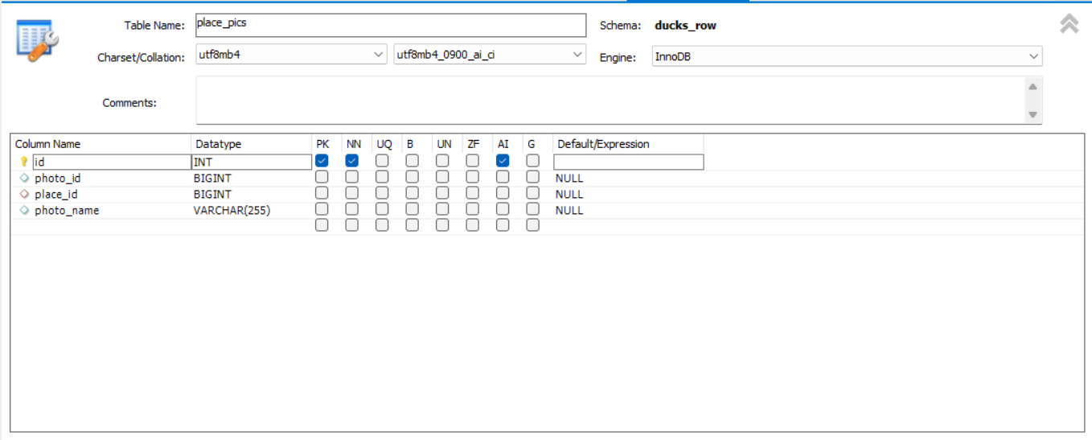

Figure 24 Places pics Database

* **The offers ‘table’ holds the photos of the offers that appears to the user on the website with the ‘offer_id’ being the primary key but it doesn’t contain any foreign keys**

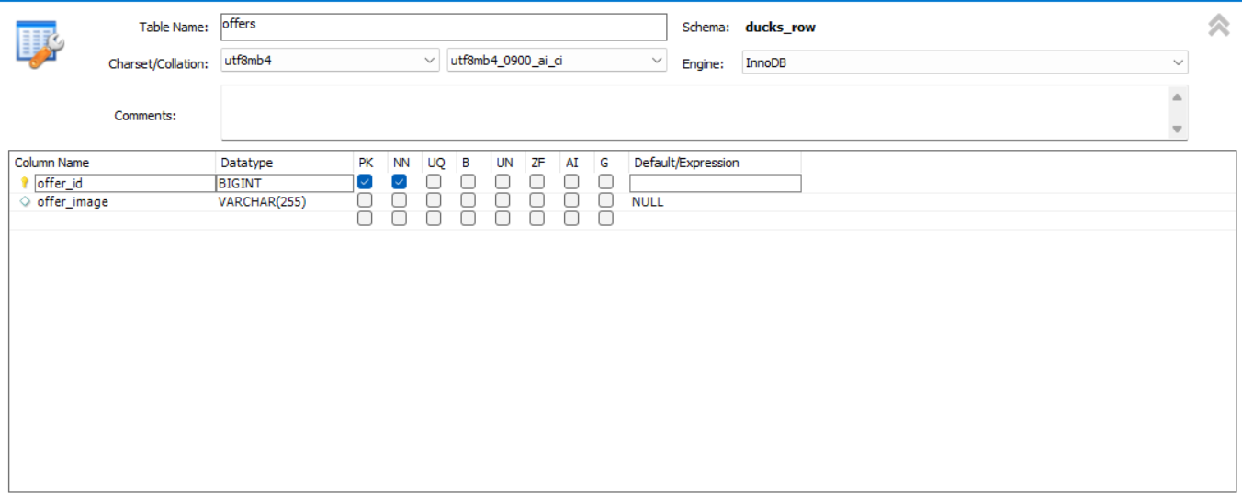

Figure 25 Offers Database

* **The ‘user_plans’ tables holds all the information about the plan that the user create in the website with the ‘plan_id’ being the primary key of the table and the ‘user_id’ being the foreign key connecting the ‘user_plans’ table with the ‘users’ table**

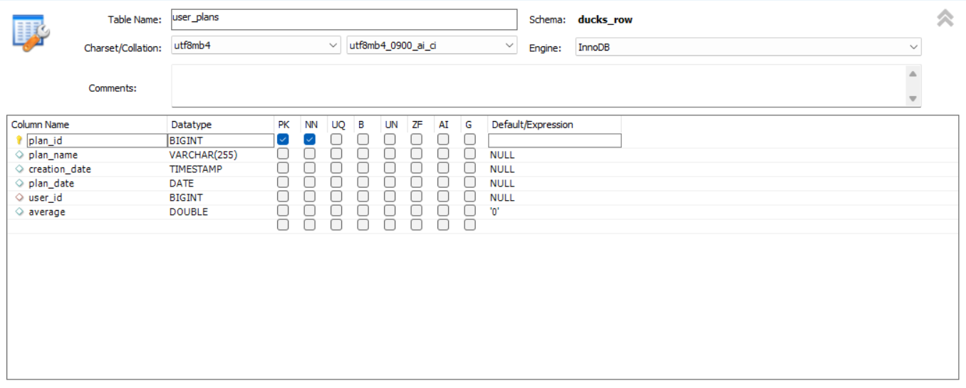

Figure 26 Users plans Database

* **The ‘exist_plan’ table holds all the information about the existed plans made by the user with the id being the primary key, the plan_id being the foreign key connecting the ‘user_plan’ with the ‘exit_plan’ table and the ‘place_id’ being the other foreign key connecting the ‘exit_plan’ with the ‘exit_plan’**

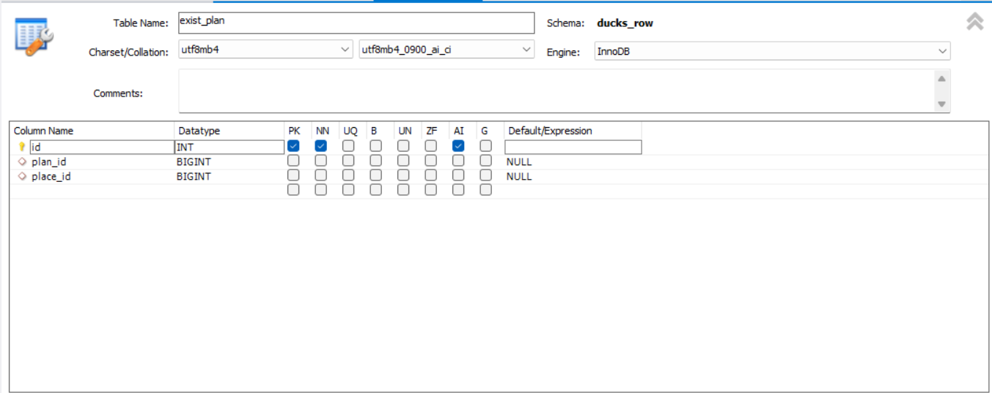

Figure 27 Exist plan Database

* **The ‘requests’ table is mainly used in case someone wanted to add his/her own place to our website then he fills a specific form and the data inside it gets sent to the admins to be approved or not with the ‘request_id’ being the primary key and the ‘user_id’ being a foreign key connecting the ‘requests’ table with the ‘users’ table**

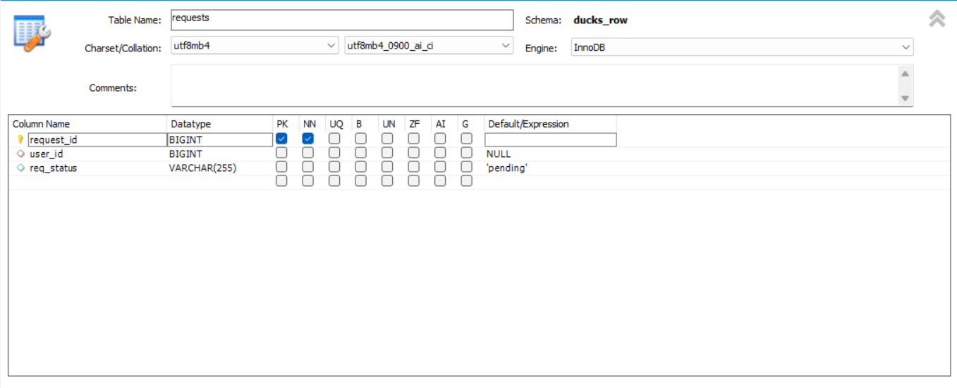

Figure 28 Requests Database

* **The ‘request_comment’ table holds a brief comment that will appear to the user if their request didn’t get approved, with the id being the primary key and the ‘place_id’ being the foreign key that connects the ‘request_comments’ table with the ‘request_details’ table**

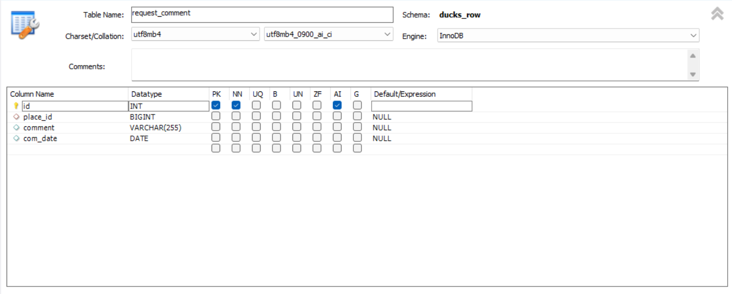

Figure 29 Request comment Database

* **The ‘request_details’ table holds the full information about the given request by the user with the ‘place_id’ being the primary key and the request id being the foreign key that connects the ‘request_details’ table with the ‘requests’ table**

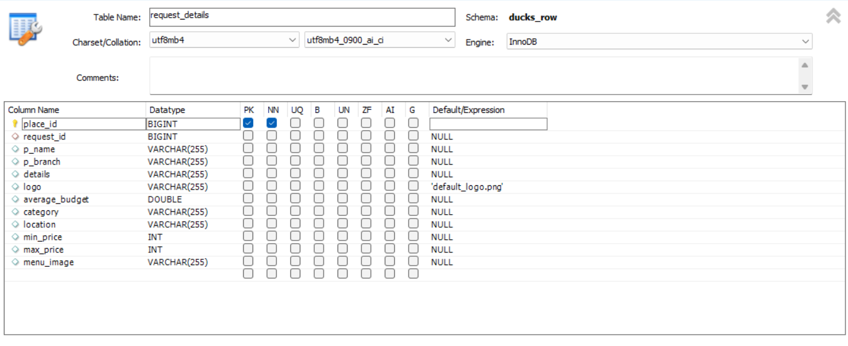

Figure 30 Request details Database

* **The ‘request_place_pics’ table holds the photos of the inserted places through the request made by the user with the ‘photo_id’ being the primary key and the ‘place_id’ being the foreign key connecting the ‘request_place_pics’ with the places table**

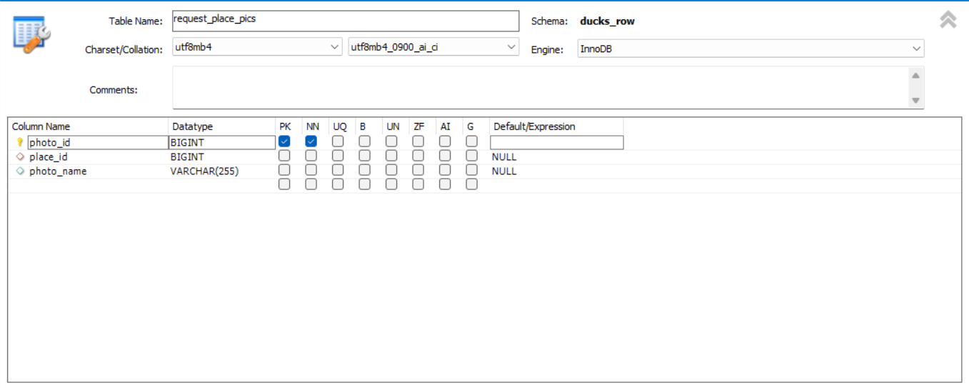

Figure 31 Request place pics Database

* **The ‘review_table’ table holds the reviews and ratings of all users in each place with ‘review_id’ being the primary key, ‘place_id’ being the first foreign key connecting the ‘review_table’ with the places table and the other foreign key is ‘user_id’ that connects the ‘review_table’ with users table**

**CHAPTER 4**

**REAL WORLD APPLICATION**

# CHAPTER 4

## 6 REAL WORLD APPLICATION

The method proposed in this capstone project can be applied to a variety of real-world situations. For example, it could be used by people who are planning a vacation, a day trip, or even just a night out with friends. The method could also be used by businesses to help their employees plan social events.

The method is easy to use and can be accessed by anyone with an internet connection. It is also free to use, making it a cost-effective option for people who are on a budget.

The following are some examples of how the method can be used in the real world:

* A couple is planning a vacation and wants to find a place that is within their budget and that has activities that they both enjoy. They can use the method to search for places that meet their criteria and to compare prices.
* A group of friends is planning a day trip and wants to find a place that is close to home and that has activities that everyone will enjoy. They can use the method to search for places that meet their criteria and to get directions.
* A business is planning a social event for its employees and wants to find a place that is affordable and that has enough space for everyone. They can use the method to search for places that meet their criteria and to get quotes from different vendors.

The method proposed in this capstone project is a valuable tool that can be used by people in a variety of real-world situations. It is easy to use, free to use, and effective in helping people plan entertainment times that meet their needs and budget.

Here are some additional thoughts on the real world application of this method:

* The method could be used to help people plan entertainment times in different cities or countries. This could be helpful for people who are planning a vacation or who are new to an area.
* The method could be used to help people plan entertainment times for special occasions, such as birthdays, anniversaries, or holidays. This could help people to find unique and memorable activities to do with their friends and family.
* The method could be used to help people plan entertainment times that are specific to their interests. For example, People who are interested in art could use the method to find art museums or galleries.

Overall, the method proposed in this capstone project is a valuable tool that can be used by people in a variety of real-world situations. It is easy to use, free to use, and effective in helping people plan entertainment times that meet their needs and budget.

### **Related works**

Online reviews have become an increasingly important part of the consumer decision-making process. Studies have shown that online reviews can have a significant impact on purchase decisions, especially for experience goods, such as hotels and restaurants.

One study by Xiang et al. (2008) found that consumers who read online reviews are more likely to book a hotel than those who do not. The study also found that the number of reviews and the average rating of a hotel are both positively correlated with the hotel's booking rate.

Another study by Ghose and Ipeirotis (2006) found that online reviews can have a significant impact on the sales of books. The study found that books with more reviews and higher ratings are more likely to be purchased than those with fewer reviews and lower ratings.

These studies suggest that online reviews can have a significant impact on consumer behavior. This is important for businesses that want to attract customers and increase sales.

In the context of our capstone project, online reviews can be a valuable tool for helping teenagers to make informed decisions about where to hang out. By including a section on online reviews on your website, you can provide teenagers with access to a wealth of information about different entertainment times. This information can help teenagers to find entertainment times that are within their budget and that meet their interests.

In addition to including a section on online reviews, also that our website is easy to use and that the information is easy to find. This will help teenagers to find the entertainment times that they are looking for.

**CHAPTER 5**

**Conclusion and**

**Future Work**

# CHAPTER 5

## CONCLUSION AND FUTURE WORK

### **1** **Conclusions**

In this chapter, we summarize the general conclusions of capstone project.

In this project, we have addressed the problem of planning a entertainment time with friends or alone, taking into account the user's budget and preferences. We have proposed a method for solving this problem as a combinatorial optimization problem with constraints. Our method takes into account the following factors:

* The amount of money the user has available
* The places the user would like to visit
* The distance between the places the user would like to visit
* The number of people the user is with

We have implemented our method as a website, which allows users to enter their preferences and budget and then receive a list of recommendations for entertainment times that meet their criteria. We have evaluated our website with a user study and found that it is effective in helping users plan entertainment times that meet their needs.

### **2 Future Work**

Many different adaptations, tests, and experiments have been left for the future due to lack of time (i.e. the experiments with real data are usually very time consuming, requiring even days to finish a single run). Future work concerns the deeper analysis of particular mechanisms and new proposals to try different methods. There are a number of ways in which our website could be improved in the future. For example, we could:

* Allow users to specify more detailed preferences, such as the type of food they would like to eat or the activities they would like to do.
* Other factors include the type of entertainment you will enjoy in, such as going out with friends, family, or on a date.
* Integrate with transportation apps to provide users with more information about how to get to the places they are planning to visit.

We believe that our website has the potential to be a valuable tool for people who are looking for ways to plan entertainment times that meet their needs. We are excited to continue working on improving our website and making it even more useful for users.

**Bibliography**

# Bibliography

1. Jon Duckett, "HTML and CSS: Design and Build Websites", John Wiley & Sons, 2011.
2. Robin Nixon, "Learning PHP, MySQL & JavaScript: With jQuery, CSS & HTML5", O'Reilly Media, 2014.
3. David Flanagan, "JavaScript: The Definitive Guide", O'Reilly Media, 2020.
4. Bogdan Brinzarea, Cristian Darie, and Audra Hendrix, "AJAX and PHP: Building Modern Web Applications 2nd Edition", Packt Publishing, 2009.
5. Luke Welling and Laura Thomson, "PHP and MySQL Web Development", Addison-Wesley Professional, 2016.
6. Jennifer Niederst Robbins, "Learning Web Design: A Beginner's Guide to HTML, CSS, JavaScript, and Web Graphics", O'Reilly Media, 2018.
7. Larry Ullman, "PHP for the Web: Visual QuickStart Guide", Peachpit Press, 2016.
8. Douglas Crockford, "JavaScript: The Good Parts", O'Reilly Media, 2008.
9. Edmond Woychowsky, "AJAX: Creating Web Pages with Asynchronous JavaScript and XML", Prentice Hall, 2006.
10. David Powers, "PHP Solutions: Dynamic Web Design Made Easy", Friends of ED, 2014.
11. Shay Howe, "Learn to Code HTML & CSS: Develop & Style Websites", New Riders, 2014.
12. Kevin Yank and Andrew Tetlaw, "Simply JavaScript", SitePoint, 2007.